FINAL PROJECT

THEORETICAL CONCEPT

- Online Master Model -



Agritech in Syria:
Agrisyria App for Pest Management and Crop Protection

Agriculture and Digital Technology

The project focuses on applying digital tools to enhance agriculture in Syria. After years of conflict, the Syrian agricultural sector requires support in crop production to improve the livelihoods and resilience of local communities. The Agrisyria App is a digital solution that boosts pest management and crop health.

Anna Micheletto, Italy

ABSTRACT

The Agrisyria App is an innovative digital platform that empowers Syrian farmers to manage pests and diseases that impact crop health and productivity. It provides real-time monitoring and technical help to support farmers with integrated pest management (IPM) approaches (Kogan, M., 1998; Ehler et al., 2006). The app is a tool that links agronomists, technicians, and farmers, simplifying their ability to manage pests independently and sustainably. The expected outcomes include improved pest control, reduced reliance on phytosanitary products, and increased awareness of environmental and human health impacts. Ultimately, the Agrisyria App aims to enable resilient, self-sufficient farming practices aligned with Syria's post-conflict recovery goals, inspiring hope for a sustainable agricultural future and empowering local farming communities (FAO, 2023).

INTRODUCTION AND MAIN QUESTIONS
Introduction:
The Agrisyria App is a digital tool that addresses urgent pest management challenges and crop disease control within Syria's post-conflict agricultural areas. Pest and disease outbreaks significantly affect crop yields; traditional methods are often costly or inaccessible. The Agrisyria App provides a free digital tool for real-time pest monitoring and integrated pest management (IPM) methods, merging technology with local knowledge to improve crop resilience and sustainability in challenging environments (Kogan, M., 1998; Ehler et al., 2006).

Significance in Current Issues of Cooperation and Development:
The Agrisyria App follows global efforts to integrate technology into agriculture, contributing to achieving two Sustainable Development Goals of Agenda 2030, specifically Goal 2 (Zero Hunger) and Goal 12 (Responsible Consumption and Production). The app will advise using efficient and sustainable pest management techniques to reduce dependence on chemical pesticides. This supports environmental health and likewise delivers essential tools that promote resilience among rural communities.

Main Questions:

• How does the Agrisyria App improve pest management and crop protection in Syria?
• What specific contributions does the app make toward sustainable agriculture and
environmental health?
• How effective is the app in building local capacity for independent, science-based pest.
management?

OBJECTIVES

The main objectives of the Agrisyria App project are:

• Provide Syrian farmers with free, accessible, real-time pest and disease monitoring data.
• Support integrated pest management practices, reducing reliance on chemical pesticides.
• Increase crop yield and farmers' livelihoods by employing sustainable crop protection
plans.
• Reduce the digital divide by delivering training, offline options, and SMS notifications
(Venkatesh et al., 2003).

METHODOLOGY AND RESEARCH METHODS
The methods will include data collection and analysis to evaluate the app's service, accessibility, and contributions to local agricultural practices. Moreover, this digital tool satisfies the needs of Syrian farmers assessed by the PRA (Participatory Rural Appraisal).

Data Collection and Anticipated Sources
Primary data collection will focus on farm spatial data, detailed crop information, and pest monitoring. The Agrisyria App is designed to collect geo-coordinates on the farms, crop types, and growth stages directly from farmers and technicians, aligning with IPM principles (Kogan, M., 1998; Maredia et al., 2003; Ehler et al., 2006; Mani et al., et al., 2021). Research indicates that digital IPM tools enhance pest control by providing localised, fast information.
A detailed pest catalogue within the app will help farmers take scientifically informed preventive measures to reduce crop losses and health.

Data Collection for Analysis

We will examine trends in pest infestations, crop health metrics, and user adoption rates. Spatial mapping within the app allows for preventive interventions based on pest outbreaks, an approach supported by studies such as Maredia et al. (2003) and Mani et al. (2021), which underline the importance of georeferenced data. Data on user satisfaction and the app's effect on pest control will be collected via interviews with farmers and agronomists. Around 2,000 farmers from selected Syrian regions will be included, providing a complete dataset to evaluate the app's impact. The analysis will include individual farmers' feedback, pest incidence rates, and crop yield improvements, allowing comparative analysis across various results.

Challenges

Challenges include limited internet access in rural areas, which could interrupt data transmission. Besides, the app's smartphone dependency might introduce obstacles for users with little digital knowledge. To address the problems, we planned training sessions and offline features to be implemented as suggested by Venkatesh et al. (2003).

Technological Innovation and Accessibility Challenges

The Agrisyria App uses GPS, GIS mapping, and real-time notifications for precise pest management and efficient resource use, identifying pest outbreaks and supporting targeted interventions (Maredia et al., 2003; Mani, P. K. et al., 2021). However, accessibility remains a concern due to smartphone and internet dependency, especially in remote areas. To address these challenges, the app will incorporate offline capabilities and SMS-based notifications to reach users in low-connectivity areas (Venkatesh et al., 2003; Rotz et al., 2019). Multilingual support and tailored workshops will promote broader adoption, crossing digital divides and enhancing accessibility in under-resourced areas.

DISCUSSION OF THE IMPLICATION OF THE MASTER PROGRAMME

The Agrisyria App project aligns with principles evidenced during the Master's program, mainly digital transformation, sustainable development, and ICT integration in international development to achieve SDG goals. By applying these concepts to agriculture in post-conflict Syria, the project demonstrates how technology can effectively address development challenges and foster resilience and stabilisation of the Syrian population (FAO, 2023). Moreover, this digital tool satisfies the needs of Syrian farmers assessed with the PRA method (Participatory Rural Appraisal). Following the principles of PRA, as Cavestro (2003) outlined, the Agrisyria App project emphasises a bottom-up approach involving Syrian farmers directly in pest management and crop protection. This method aligns closely with the app's philosophy of empowering farmers through free digital tools.

Digital Transformation in Agriculture
One critical insight from the Master's program is the role of digital transformation in encouraging sustainable agriculture, especially in conflict areas and resource-limited regions. In line with FAO (2023), which supports resilience in agriculture, the app empowers local farmers, strengthening their ability to manage pests independently. Accessible digital platforms allow the transformation of traditional practices and generate efficiency within resource-constrained context. Besides, the Agrisyria App's use of GPS, data mapping, and mobile notifications are practical applications of digital tools that enhance productivity while minimising crop losses.

Sustainable Development and ICT in Agriculture
The UN's Sustainable Development Goals (SDGs) were part of the master program with a particular focus on Goal 2 (Zero Hunger) and Goal 12 (Responsible Consumption and Production). The Agrisyria App directly contributes to these goals by offering validated recommendations that reduce pesticide use and enhance crop yields sustainably. Through its application of IPM, Agrisyria reflects ecological responsibility, prioritising both environmental and human health. This essential component ties the project to global sustainability efforts, as the United Nations (2015) outlined.

Community Engagement and Participatory Development
Mirroring the principles of participatory development discussed by Chambers (1994) and Probst et al. (2003), the app enables a collaborative approach. The app is a platform for collective learning, delivering a tool for local farmers to speak with agronomists and transfer their experiences (Probst et al., 2003). Participatory methods in agriculture are essential, especially in post-conflict zones, as they improve community resilience (FAO, 2023). For this intent, the Agrisyria App is user-friendly and culturally appropriate, facilitating its use and enabling training for users with different technological skills (Probst et al., 2003).

Spatial Analysis and Data-Driven Decision-Making
The importance of GIS for mapping and data visualisation was introduced during the Master. The app helps in monitoring pest outbreaks using GIS techniques. Moreover, experts will advise for specific interventions and practical pest management approaches.

Theoretical Models in Technology Adoption
The Master's program emphasises critical principles for addressing barriers to technology adoption in rural, low-resource settings. By prioritising ease of use and practical relevance, the Agrisyria App's design was made more accessible and aligned with local farming needs, thanks to the PRA, enhancing adoption (Rogers, 2003; Venkatesh et al., 2003). Research on technology adoption in rural contexts confirms that simplicity and perceived benefits are critical for adoption in low-resource settings (Rogers, 2003). This understanding was crucial for adapting the app to the needs of the rural Syrian communities.

DISCUSSION OF THE FINAL PRODUCT

Anticipated Outcomes and Potential Impact Analysis
The Agrisyria App is programmed to facilitate pest management and sustainable agricultural practices for Syrian farmers. Real-time data on pest presence, distribution, and severity empowers farmers to make timely and precise crop management decisions. This is critical where pest outbreaks impact the livelihoods of the local communities. With a scientific approach, the app supports adequate pest control strategies to reduce crop losses and raise productivity. Furthermore, the app gives local farmers technical pest management guidance, providing access to advanced agricultural techniques essential for those in isolated or rural areas (FAO, 2023).
Impact on Crop Protection and Pest Management
The Agrisyria App will provide a pest catalogue to help identify pests, with science-based reviews promoting autonomous decision-making. This will allow communities to tackle agricultural challenges independently, mainly in rural areas with limited expert support (FAO, 2023).
Sustainability and Reduction in Chemical Usage
The app includes an early warning system that will help reduce pesticide use in favour of sustainable practices supported by scientific recommendations. This approach addresses sustainability issues by reducing agriculture's environmental footprint, a priority emphasised by FAO (2023). The Agrisyria App contributes to soil and ecosystem long-term health and supports biodiversity by reducing chemical inputs. Moreover, the app data collection will enable sustainable agricultural practices in a changing ecosystem (Pretty et al., 2011).

Technological Innovation and Accessibility Challenges
The Agrisyria App analyses pest outbreaks using GPS, GIS mapping, and notifications. Targeted interventions and sustainable resource use will be adapted to each case. Nevertheless, reliance on smartphones and internet access threatens its use in rural and isolated areas. The app can also be used offline (SMS notifications and a pest catalogue) to avoid these barriers. This commitment to inclusivity ensures accessibility despite technological limitations (Rotz et al., 2019; Venkatesh et al., 2003).
User Experience and Feedback Integration
Feedback based on users will be critical to improve the app's usability. This approach wants to make the app user-friendly, enabling its use among different user groups. Research on agricultural technology adoption shows that user-centred design enhances adoption and long-term use, especially when tools are designed for specific local contexts and available in the local language (Rogers, 2003; Venkatesh et al., 2003).
Areas for Improvement and User Support
Training and user support are essential for the app to be used successfully. Training programs are planned to instruct on data entry precision, on pest management practices, and the development of users' digital skills. These interventions will enable farmers to be independent in pest management. Good data collection is necessary to help deliver practical pest management suggestions. This commitment supports the participatory development principles (Chambers, 1994; Probst et al., 2003).
Long-Term Vision and Broader Implications
The project presents a replicable model that could be adopted in different environmental and social contexts. Promoting responsible agricultural practices that enhance food security and environmental health aligns with the United Nations Sustainable Development Goals, as evidenced in previous paragraphs (United Nations, 2015).

10. CONCLUSIONS

The Agrisyria App is a valuable digital tool for promoting sustainable agricultural practices. The app will provide Syrian farmers with agricultural competencies by providing real-time data collection, scientific recommendations, and mapping, enabling them to protect crops effectively and encourage pesticide use according to IPM principles. Promoting more sustainable pesticide use and supporting better ecological practices could significantly decrease crop losses, increase yields, and minimise environmental impact.
Another potential of the Agrisyria App is its ability to connect farmers with scientific experts, which might usually be difficult in post-conflict regions (FAO, 2023).
The project also underscores the importance of ICT in agriculture, demonstrating how digital tools could be adapted to other regions facing similar agricultural and infrastructural challenges. Still, the app's full functionality, which depends on an internet connection and smartphones, stresses potential barriers in rural areas. Future adaptations could improve accessibility through more offline capabilities.
As Syria continues its recovery, tools like the Agrisyria App have the potential to contribute meaningfully to a socially accepted and sustainable future in Syrian agriculture, improving food security while sustaining livelihoods.

Confidentiality Disclaimer

This document includes detailed information on the Agrisyria App, an ongoing project currently in development and not yet available for public release. The content, including descriptions of features, functionalities, and data methodologies, is proprietary and confidential, intended solely for academic evaluation within the framework of this Master thesis. As an active team member at CIHEAM Bari working on this project in collaboration with the Italian Agency for Development Cooperation and Ingenia, I am directly involved in the app’s development. Unauthorized disclosure, distribution, or reproduction of any part of this document is strictly prohibited, as it may compromise the proprietary integrity of the project and our partners' strategic interests.

REFERENCES

Cavestro, L. (2003). PRA-participatory rural appraisal concepts methodologies and techniques. Padova University. Padova PD. Italia.

Chambers, R. (1994). The origins and practice of participatory rural appraisal. World Development, 22(7), 953–969.

Ehler, L. E. (2006). Integrated pest management (IPM): Definition, historical development and implementation, and the other IPM. Pest Management Science, 62(9), 787-789.

Food and Agriculture Organization of the United Nations (FAO). (2023). Developing sustainable and resilient agrifood value chains in conflict-prone and conflict-affected contexts. Rome: FAO.

Kogan, M. (1998). Integrated pest management: Historical perspectives and contemporary developments. Annual Review of Entomology, 43(1), 243-270.

Mani, P. K., Mandal, A., Biswas, S., Sarkar, B., Mitran, T., & Meena, R. S. (2021). Remote sensing and geographic information system: A tool for precision farming. In Geospatial technologies for crops and soils (pp. 49-111). Springer.

Maredia, K. M., Dakouo, D., & Mota-Sanchez, D. (2003). Integrated pest management in the global arena. In Integrated pest management and spatial data analysis: Potential for targeted intervention in rural agricultural communities (pp. 203-215). Wallingford, UK: CABI Publishing.

Pretty, J., Toulmin, C., & Williams, S. (2011). Sustainable intensification in African agriculture. International Journal of Agricultural Sustainability, 9(1), 5-24.

Probst, K., Hagmann, J., & Ashby, J. A. (2003). Understanding participatory research in agricultural research and development. Development in Practice, 13(3), 358-366.

Rogers, E. M. (2003). Diffusion of innovations (5th ed.). New York, NY: Free Press.

Rotz, S., Gravely, E., Mosby, I., Duncan, E., Finnis, E., Horgan, M., LeBlanc, J., Martin, R., Tait Neufeld, H., Pant, L., & Shalla, V. (2019). Automated pastures and the digital divide: How agricultural technologies are shaping labour and rural communities. Journal of Rural Studies, 68, 112–122.

United Nations. (2015). Transforming our world: The 2030 agenda for sustainable development. New York, NY: United Nations.

Venkatesh, V., Morris, M. G., Davis, G. B., & Davis, F. D. (2003). User acceptance of information technology: Toward a unified view. MIS Quarterly, 27(3), 425-478.
World Bank. (2017). ICT in agriculture: Connecting smallholders to knowledge, networks, and institutions. Washington, DC: World Bank.

APPENDIX: MATERIALS & PROTOTYPES

- Prototype Screenshots:

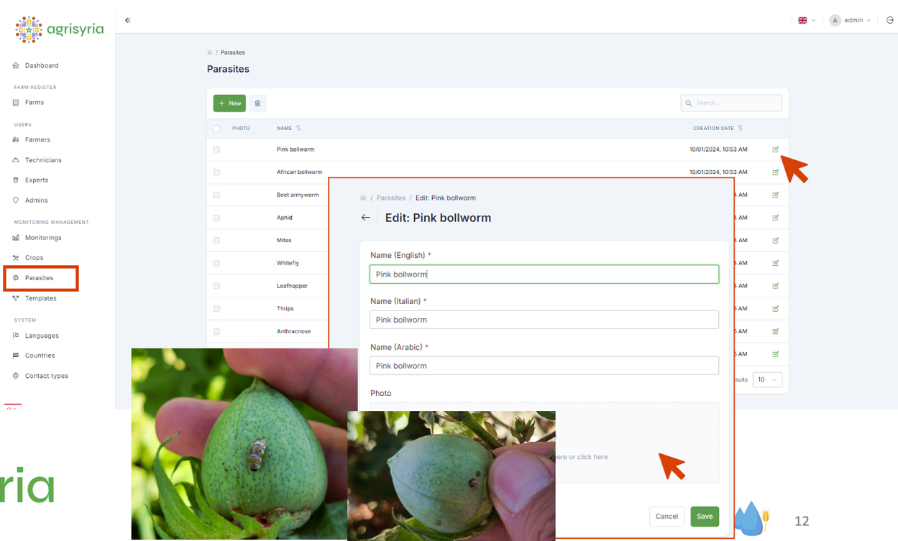

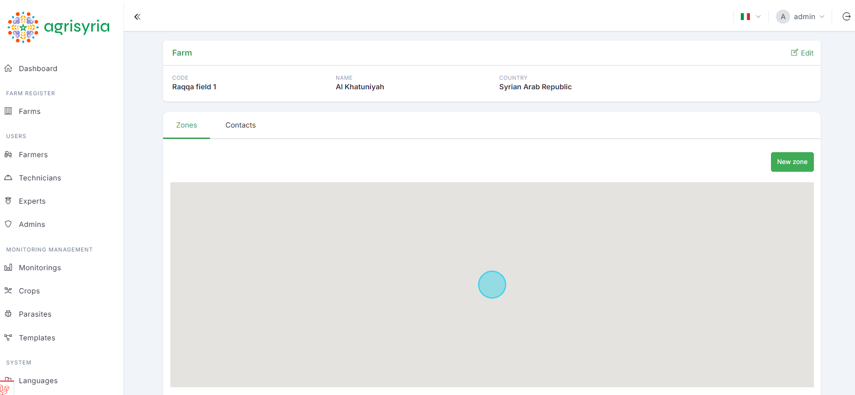
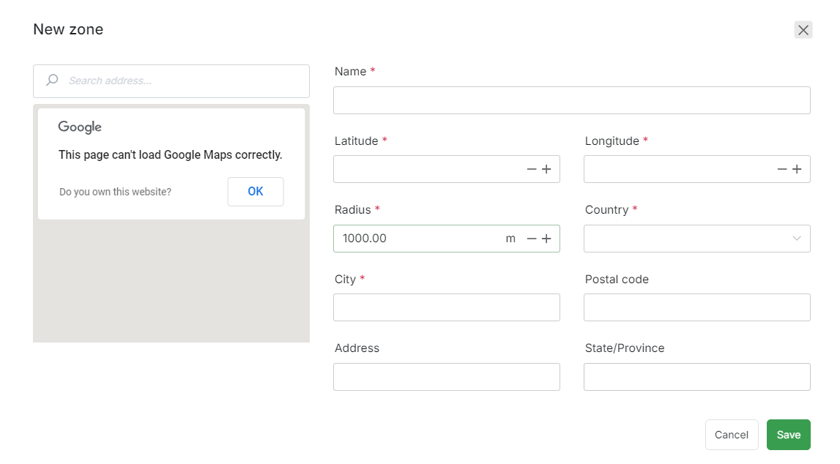

- Evaluation Questionnaire to use during Agrisyria App presentation and workshops

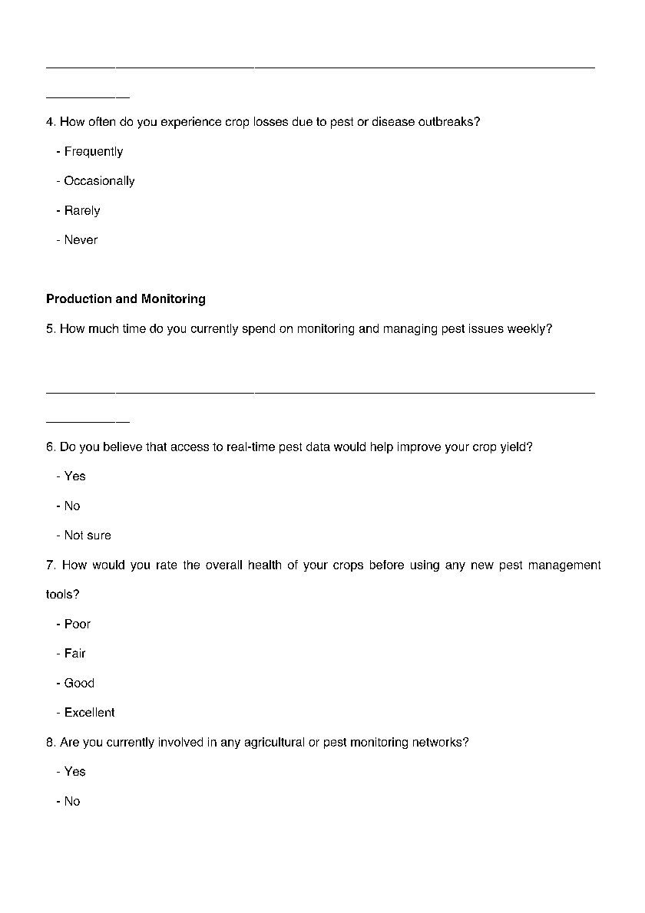
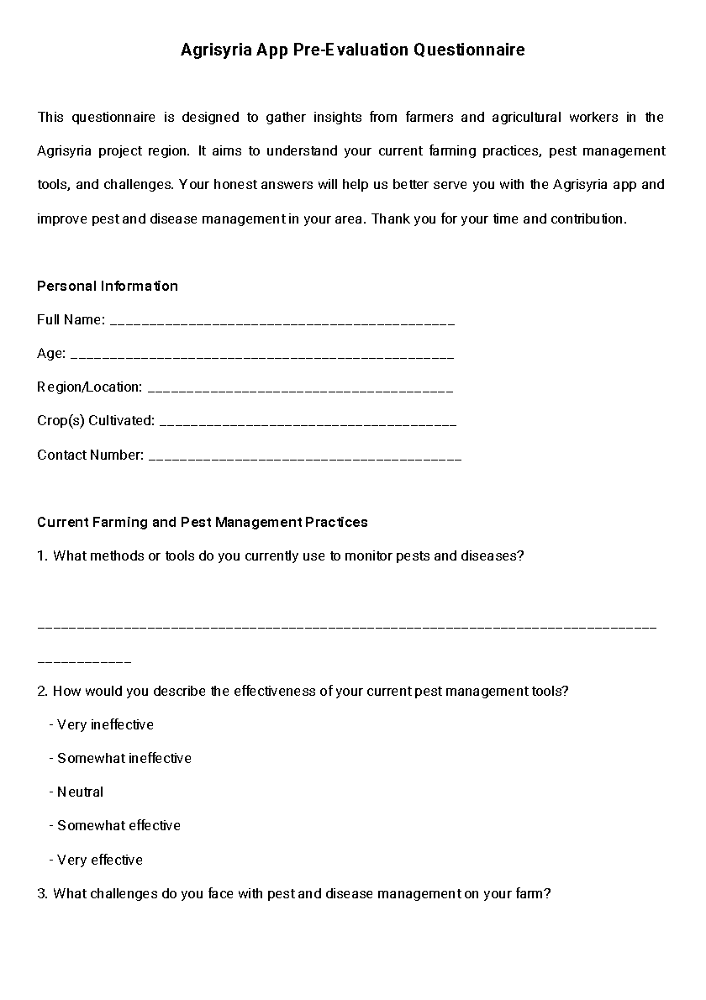

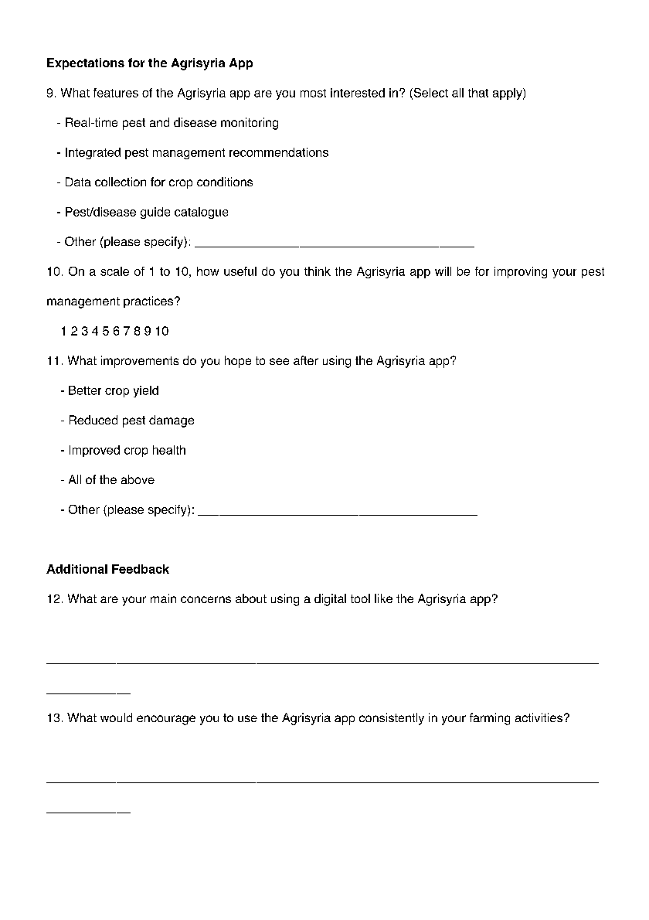

- App Visibility campaign


